* Acquiring a lease for a blob is acquiring the lock on the blob to make changes and re write the files.
* We need to use lease id with the request after we acquire a lease for a blob.
* 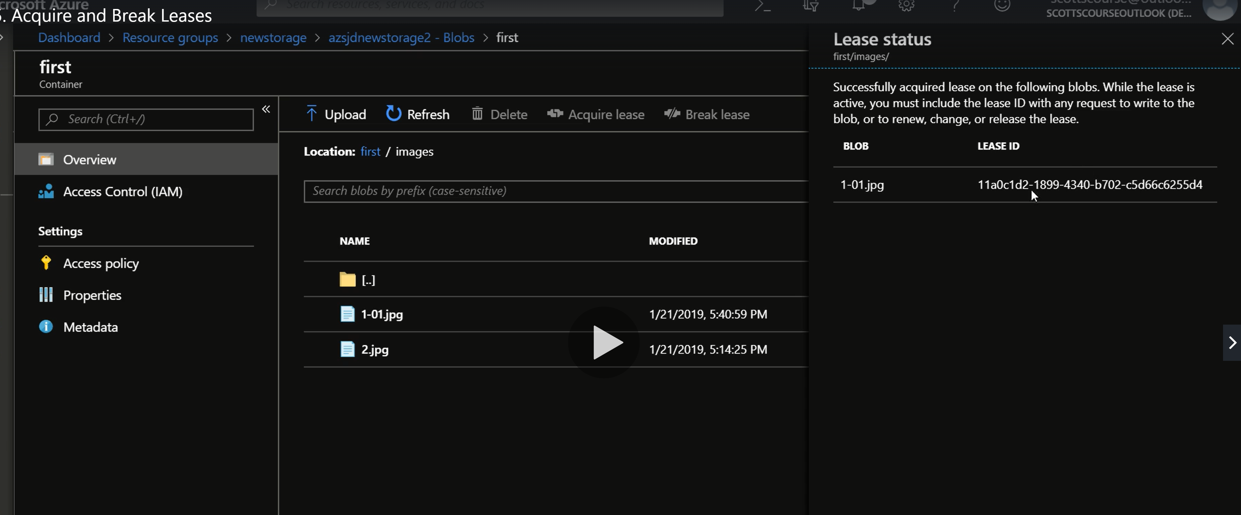
* Break the lease when the job is done. This way others can use the file.

**Storage Access Tiers**

* Hot, Cool and Archive are the access tiers in which files can be kept according to the frequency of its accessibility for use. Hot is frequent access and more price to store.
* Accessibility can be changes from blob properties.
* Storage becomes cheaper and access becomes costly.
* <https://docs.microsoft.com/en-us/azure/storage/blobs/storage-blob-storage-tiers?tabs=azure-portal>
* Access Tier plans
* 